ASSIGNMENT 4

| ASSIGNMENT DATE | 21 OCTOBER 2022 |
| --- | --- |
| STUDENT NAME | HARIHARAN S |
| TEAM ID | PNT2022TMID04914 |
| MAXIMUM MARKS | 2 MARKS |

SOLUTION:

KUBERNETES

**Deployment.html**

apiVersion: apps/v1 kind: Deployment metadata:

name: flask-app

spec: replicas: 3 selector:

matchLabels: app: flask-app

template: metadata: labels:

app: flask-app

spec:

containers:

- name: webpage

image: Assignment/flask imagePullPolicy: Never ports:

- containerPort: 5000 protocol: TCP

service.yaml

apiVersion: v1 kind: Service metadata:

name: flask-app-service spec:

type: ClusterIP ports:

- port: 5000 selector:

app: flask-app

**base.html**

<!DOCTYPE html>

<html lang="en">

<head>

<meta charset="UTF-8">

<title> FlaskApp</title>

<style>

.message { padding: 10px; margin: 5px;

background-color: #656362

}

h1{

color: #1d78cd;

}

nav a {

color: #1d78cd; font-size: 25px; margin-left: 50px;

text-decoration: none;

text-transform: uppercase;

}

.alert {

padding: 20px; margin: 5px; color: #977c30;

background-color: #dda1ae;

}

.button {

background-color:#977c30; /* red */ border: none;

color: white; padding: 16px 32px; text-align: center;

text-decoration: none; display: inline-block; font-size: 16px; margin: 4px 2px;

transition-duration: 0.4s; cursor: pointer;

}

.button1 {

background-color: white; color: black;

border-radius: 10px; border: 2px solid #036523;

}

.button1:hover {

background-color: #00971e; color: rgb(47, 41, 51);

}

input[type=text],textarea { width: 50%;

padding: 12px 20px; margin: 8px 0;

box-sizing: border-box; border: 2px solid; border-radius: 4px;

}

</style>

</head>

<body>

<nav>

<a href="#">Home</a>

<a href="{{ url_for('index') }}">FlaskApp</a>

<a href="{{ url_for('create') }}">Create</a>

</nav>

<hr>

<div class="content">

{% for message in get_flashed_messages() %}

<div class="alert">{{ message }}</div>

{% endfor %}

{% block content %} {% endblock %}

</div>

</body>

</html>

**create.html**

<!DOCTYPE html>

<html lang="en">

<head>

<meta charset="UTF-8">

<title> FlaskApp</title>

<style>

.message { padding: 10px; margin: 5px;

background-color: #656362

}

h1{

color: #1d78cd;

}

nav a {

color: #1d78cd; font-size: 25px; margin-left: 50px;

text-decoration: none;

text-transform: uppercase;

}

.alert {

padding: 20px; margin: 5px; color: #977c30;

background-color: #dda1ae;

}

.button {

background-color:#977c30; /* red */ border: none;

color: white; padding: 16px 32px; text-align: center;

text-decoration: none; display: inline-block; font-size: 16px; margin: 4px 2px;

transition-duration: 0.4s;

cursor: pointer;

}

.button1 {

background-color: white; color: black;

border-radius: 10px; border: 2px solid #036523;

}

.button1:hover {

background-color: #00971e; color: rgb(47, 41, 51);

}

input[type=text],textarea { width: 50%;

padding: 12px 20px; margin: 8px 0;

box-sizing: border-box; border: 2px solid; border-radius: 4px;

}

</style>

</head>

<body>

<nav>

<a href="#">Home</a>

<a href="{{ url_for('index') }}">FlaskApp</a>

<a href="{{ url_for('create') }}">Create</a>

</nav>

<hr>

<div class="content">

{% for message in get_flashed_messages() %}

<div class="alert">{{ message }}</div>

{% endfor %}

{% block content %} {% endblock %}

</div>

</body>

</html>

**index.html**

{% extends 'base.html' %}

{% block content %}

<h1 style="text-align: center;">WELCOME!</h1>

<h1> {% block title %} <span style="color: rgb(29, 11, 166);">WRITE YOUR MESSAGES</span> {% endblock %}</h1>

{% for message in messages %}

<div class='message'>

<h3><span style="color: rgb(255, 255, 255);">TITLE : </span>

{{ message['title'] }}</h3>

<p><span style="color: rgb(255, 255, 255);">MESSAGE :

</span>{{ message['content'] }}</p>

</div>

{% endfor %}

{% endblock %}

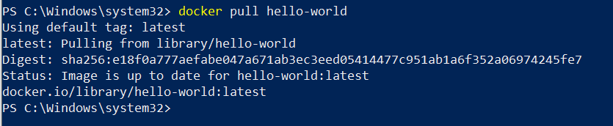

# Dockerfile

FROM python:3.10-buster WORKDIR /app

COPY . .

RUN pip install --no-cache-dir -r requirements.txt CMD ["ibm_db2", "--bind", "0.0.0.0:5000", "app:app"]

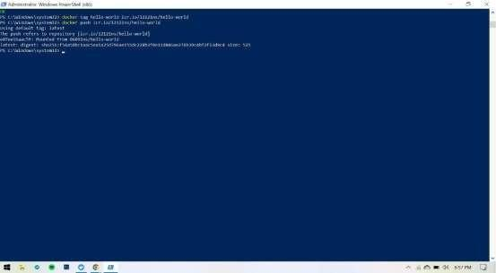

## Create a Kubernetes cluster in IBM cloud and deploy hello world image or job portal image and also expose the same app to run in nodeport.

